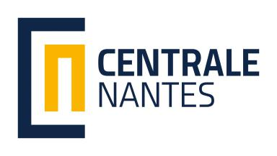
南特中央理工大学交换生项目申请表格
Ecole de Centrale Nantes
Application form for Foundation Master program
（to fill in English unless otherwise stated）

基本信息Basic Information
就读院校Home University
姓名Name in Chinese： 性别Gender： 男Male 女female
Name in English(与护照一致)：
ID card number（身份证号）
出生日期Date of Birth：
联系电话Mobile phone：
邮箱Email:
年级Current Grade: 大三Benke 3 大四 Benke 4 研一 M1
就读学院College or School
所读专业Specialty
专业平均成绩Average Score
英语水平English level 雅思IELTS 或托福TOEFL
如未考试，计划何时考？If no score, when you will take the test?

申请专业Specialty Applied
基础硕士Foundation Master
Mechanics and Environment
Signal Control and Robotics
Civil and Environmental Engineering

你可能感兴趣的硕士项目Master program you are interested
Marine Technology (M-TECH)
Hydrodynamics for Ocean Engineering (M-TECH HOE)
Atlantic Master on Ship Operation & Naval Engineering (M-TECH AMASONE)
Mechanical Engineering (M-ENG)
Advanced Manufacturing (M-ENG AM) formerly Design of Systems and Products
Computational Mechanics (M-ENG CM)
Energetics and Propulsion - (M-ENG EP)
Materials, Processes and Technology of Composites (M-ENG MPTC)
Control and Robotics (CORO)
Signal and Image Processing (CORO SIP)
Advanced Robotics (CORO IMARO)
Embedded Real Time Systems (CORO ERTS)
Control Systems (CORO CSYS)
Supervision - Production Management (CORO SPM)
Civil Engineering (C-ENG)
Materials and Structures in their Environment (C-ENG MSE)
City and Urban Environments (U-ENV)
Atmosphere, Water and Urban Environment (U-ENV AWE)
Ambiances, Architecture, Urbanity (U-ENV AAU)
Industrial Engineering (I-ENG)
Agile Factory Management (I-ENG AFM)
Smart and Connected Enterprise (I-ENG SCE)

你可能感兴趣的欧盟硕士项目
Erasmus Mundus Joint Master Degreess you are interested
MASTER OF SCIENCE IN COMPUTATIONAL MECHANICS(MCM)
EUROPEAN MASTER ON ADVANCED ROBOTICS(EMARO+)
MASTER IN RENEWABLE ENERGY IN THE MARINE ENVIRONMENT(REM)
EMSHIP ADVANCED SHIP DESIGN(EMship+)

