FEFU ARRIVAL FORM

For exchange students

Fall Semester 2019
- First Name
- Last Name
- Sending University
- I arrive on □ September 12 ; □ September 13 ;
other date of arrival to Vladivostok (local date and time in Vladivostok)
- Time of arrival (local time in Vladivostok)
- Flight number (Ship, bus, train)
- Place of arrival
- Do you need pick up service?
- Address of your dormitory in Vladivostok
- Signature

TRANSPORT INFORMATION
Plan of Airport Knevichi (Vladivostok)
ф International terminal Local terminal ф Common area
Exit
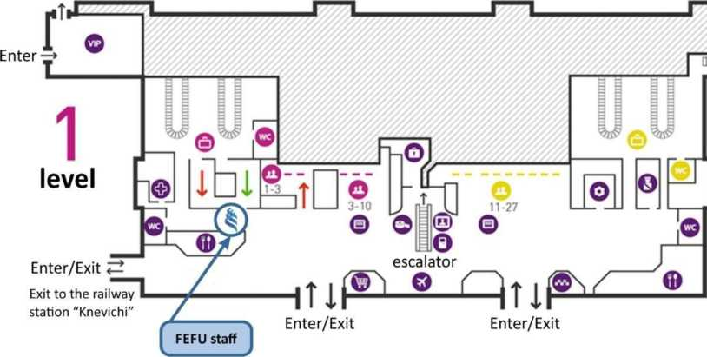

From Airport Vladivostok (Knevichi) to FEFU Campus (Dormitory No. 6-7-8-9-10-11), Russky Island
- Taxi - approx. 1000-2000 rubles
- Aeroexpress Knevichi-Vladivostok railway station Business class - 350 rubles
Economy class- 230 rubles
- Bus number 107, Knevichi-Vladivostok bus station
Cost - 150 rubles
From bus stop "Vladivostok railway station" (ZD voksal) to FEFU Campus (Dormitory No. 6-11, Russky island)
- Taxi -approx. 600 rubles
- Bus number 59, 60, 7т, 81 (cost- 23 rubles) to the bus stop "Izumrud".
On the bus stop "Izumrud", please take bus number 15 to the bus stop "Campus DVFU", Russky Island
From bus stop "Bus station" (Avtovokzal) to FEFU Campus (Dormitory No. 6-11), Russky island
- Taxi - approx. 700 rubles
- Bus number 81 to the bus stop "Izumrud", on the bus stop „Izumrud" please take bus number 15 to the bus stop "Campus DVFU", Russky island
From the bus stop "Campus DVFU" to FEFU Campus (Dormitory No. 6-11)
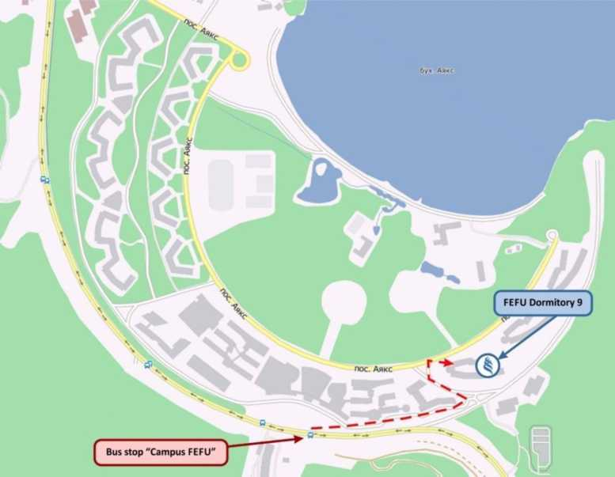

Exact dates will be informed later.
Please regard that pick up service is available just during recommended arrival dates.
Recommended time of arrival is between 9:00 AM and 5:00 PM, no pick up service after 5:00 PM is available, and no pick up service during weekends is available

