赛事规则
（一）上传的视频为５分钟（误差不超过1分钟）。
（二）视频为MP4格式，大小在100M以内。
（三）视频应在静止的位置上进行连续录制，无剪辑，无中断。视频画面可进行缩放。
（四）选手需在视频中面对观众，保证95%以上时间是在与观众交流，而不是背对观众解释PPT。
（五）演讲可使用PPT作为辅助材料，但页数一般不能超过5张。
（六）演讲中不能使用其他的电子媒体素材，如声音或视频等。
（七）演讲语言应为口语，不包括诗歌朗诵、说唱乐、歌曲等语言形式。
（八）选手不得介绍自己学校和姓名，PPT中也不能以任何形式出现相关信息。

评分标准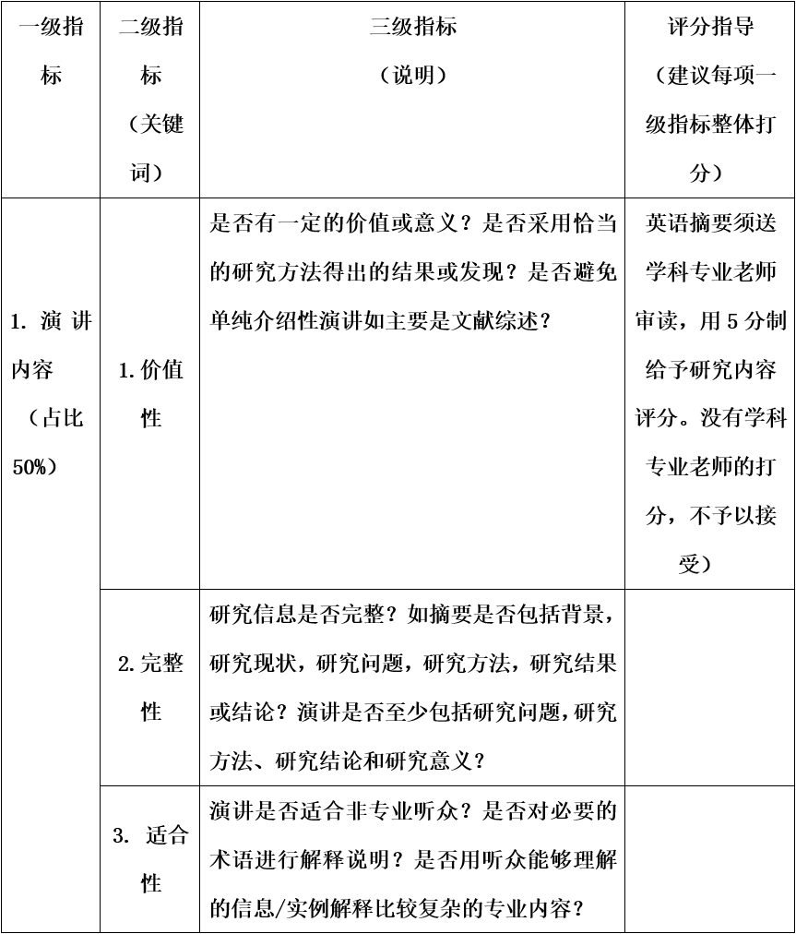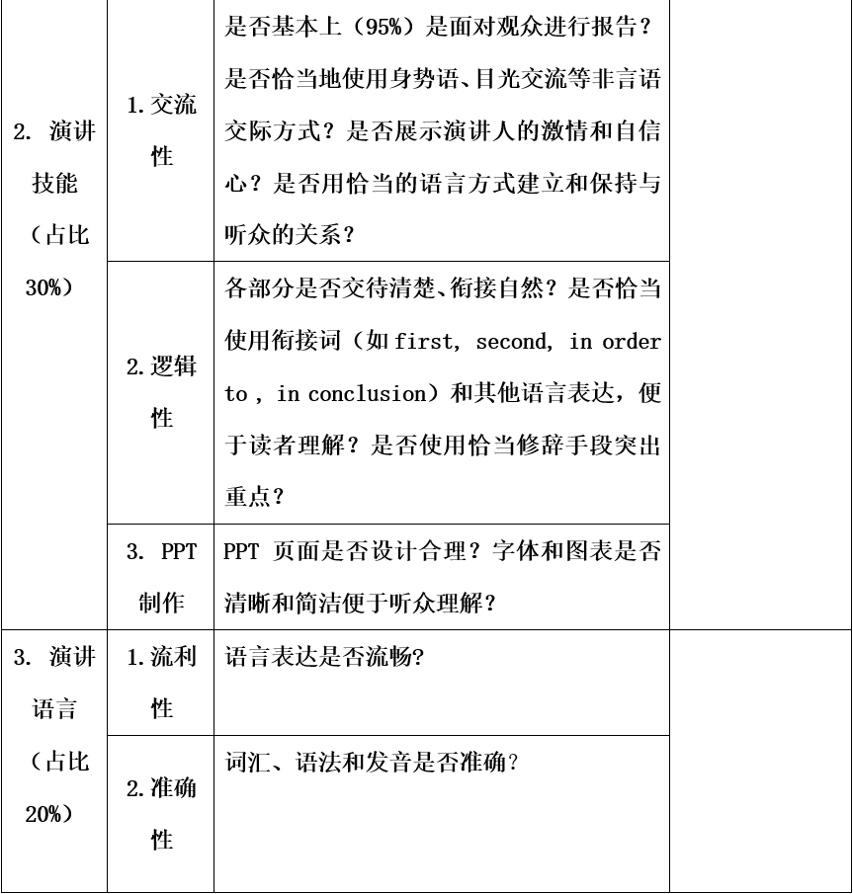

摘要样本
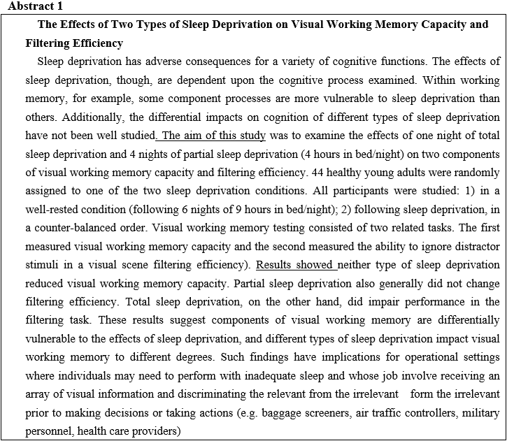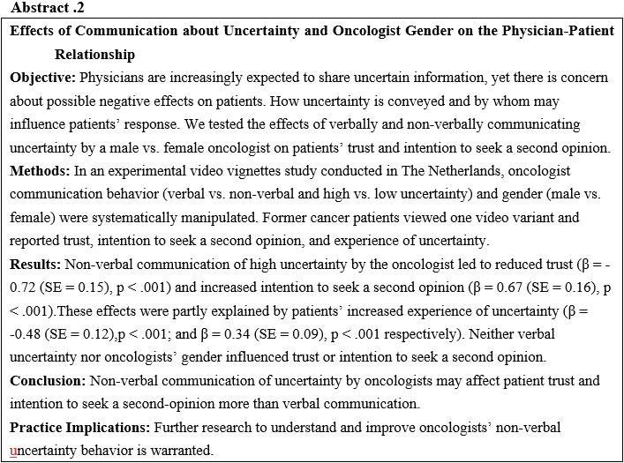
讲稿样本
(这是转录自国外3分钟科研演讲，5分钟大约550-600词)
Dengue Detective

Have you ever been bitten by mosquito? Naturally, they suck. And they bite and they make us itch. And more than that they transmit deadly diseases across the globe including dengue.
In a year, three hundred and nineteen million people fall victim to dengue. That’s like sixteen times the population of Australia today. And seventy percent of the death caused by the virus are due to one reason: a delay in detection.
I was a victim of dengue myself. Horrible experience. I had a high fever for three days. And the doctors, like the mosquito, took my blood again and again. And it was not until the fourth day that they can finally confirm that I had an infection and stop by treatment. By then I was already too weak even to drink on my own, and I had to put on drips for a whole week. I felt helpless and afraid but the worst part was having to witness other victims in my ward succumbed to dengue just because they were not treated in time. I was lucky to survive.
And I felt that nobody should die from something as trivial as a mosquito bite, right? And so I dedicated my next few years of my life to find a solution. What I ‘ve developed is a dengue sensor which is able to detect a virus more accurately and in need of much shorter time.
Meet my dengue detective. It holds three basic components: light, anti-bodies and taped optical fiber which has not been used before. What we need of patient is one tiny drop of blood. Now let me tell you how it works. Envision an underwater glass tunnel. You know you once find a Aquarium exhibitions you walk through, the sharks and fish around you. Now visualize this taped optical fiber as that glass tunnel emerges in a patient’s blood sample. And on the surface of this fiber tunnel, I mobilize anti-bodies to capture the virus. Next I transmit light to travel through this fiber tunnel and indicate the presence and quantity of the virus.
And dengue is detected and quantified.
This dengue detective holds great promise. Let me tell you why. First, it is highly sensitive and reliable. Second, it is affordable for all clinics to use. Lastly and most importantly, it is able to reduce the detection time from 4 days to just 15 minutes, which gives dengue victims a greater chance to survive. This technology is a huge step forward in the future of dengue diagnosis.
Mosquito will still suck, but this sensor would detect virus in time.

